# Video Balun Extender Transmitter For HDCVI HDTVI AHD Camera

Model:STK201P-HD-B1

>Transmit 8MP 5MP HD-TVI/AHD/HDCVI/CVBS video over one CAT5e cable.

>Screw to BNC

>SPD protection

Description of this Video Balun Extender transmitter for HDCVI HDTVI AHD camera

STK201P-HD-B1 is Single Channel Video Balun Transmitter Mini design,friendly PCB board,copper core,excellent lighting protection, ESD builted make you better and safety Single Channel Balun Extender Transmitter.

Extender Transmitter For HDCVI HDTVI Camera ,Widely used in Bank,Hospitals,school security monitor systerm,teaching industry and other complex system environment.

For many years, we have focused on manufacturing and supplying cctv passive video balun.To be productive, we maintain an attitude of excellence.Our Cctv Passive Video Balun Extender has a world-leading manufacturing level and a reasonable price.

Specification of this Video Balun Extender transmitter for HDCVI HDTVI AHD camera

|  |  |
| --- | --- |
| Model | STK201P-HD-B1 |
| Properties | |
| Transmission Signal | 1 channel |
| Transmission Distance (Max) | HDCVI 720P:400M / 1080P:250M /4MP:200M / 4K 8MP:180M (Max) |
| HDTVI 720P/1080P:250M / 5MP:200M / 4K 8MP:180M(Max) |
| AHD 720P:350M / 1080P:200M / 5MP:200M / 4K 8MP:180M(Max) |
| Category Type | UTP CAT 5E/6 (R＜10Ω/100M) |
| Video Transmission Properties And Port | |
| Coaxial Video Connector | BNC Male |
| Twisted-pair Video Connector | Push-terminal |
| Compatible Format | HDCVI, HDTVI, AHD, CVBS |
| Resolution | 720P/1080P/4MP/5MP/8MP 4K |
| Anti-interference | ＞60db |
| Protection | |
| ESD | 1a contact discharge electricity level 3 |
| 1b air discharge electricity level 3 |
| Per:IEC61000-4-2 |
| Coaxial Cable Connector | 2KV(common-code) Per:IEC61000-4-5 |
| UTP Cable Connector | 2KV(different-code),4KV(common-code),Per:IEC61000-4-5 |
| Impedance | |
| BNC Male | 75 ohms |
| UTP Cable | 100 ohms |
| Physical Properties | |
| Shell | ABS |
| Color | Black |
| N.W. | 23G |
| Stability | |
| MTBF | ＞10000H |
| Environmental | |
| Operating Temperature | -10~55℃ |
| Storage Temperature | -20~70℃ |
| Humidity | 0~95%(non-condensing) |

Application of this Economical Passive HD Video Transceiver mini design 4K 5MP

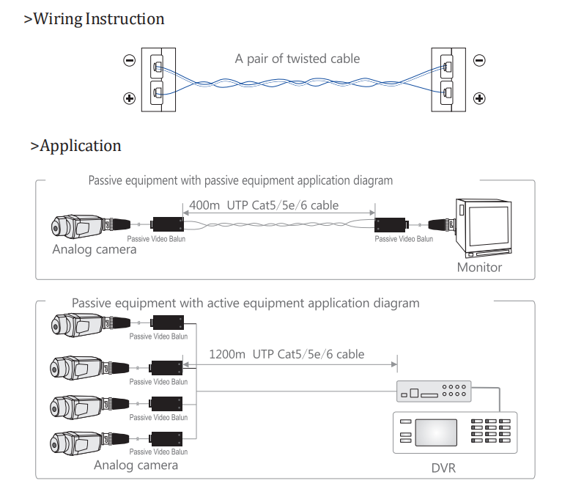

Pictures of this Video Balun Extender transmitter for HDCVI HDTVI AHD camera

