Economical Press-Fitting Terminal Model 1 Channel HD Balun
> Model number: STK201P-HD-C1
> ABS outer shell, convenient to use in intensive project
> Push-terminal with pigtail, easier for installation
> Mini size, push-terminal,easier for installation
> Economical type
Description of this Economical Press-Fitting Terminal Model 1 Channel HD Balun

STK201P-HD-C1 ctv passive video balun is a passive (non-amplified) device that allows the transmission of real-time CCTV HD video signal via cost-effective Unshielded Twisted Paired (UTP) cable. The TT-201P-HD-C1 Terminal Model HD Video Balun is compatible with all HD-TVI, HD-CVI, AHD and CVBS analog cameras.
Push-pin terminal block allows tool-less connection of UTP cable output. Used in pairs, T STK201P-HD-C1 1 Channel HD CCTV Balun eliminates costly and bulky coaxial cable.
The superior interference rejection and low emissions of the STK201P-HD-C1 Press-Fitting Terminal HD Video Balun ,allow video signals to coexist in the same wire bundle as telephone, datacom, or damaging voltage spikes. 1 Channel Passive Video Balun crosstalk and noise immunity ensure quality video signals. Widely used in security, teaching industry and other complex system environment.
Specification of this Economical Press-Fitting Terminal Model 1 Channel HD Balun

Model | STK201P-HD-C1
Properties
Transmission Signal | 1 channel
Transmission Distance (Max) | HDCVI 720P: 400M / 1080P: 250M; 4Mp:200M ;5Mp:200M; 8MP: 180M
 | HDTVI 720P/1080P: 250M; 5Mp:200M ; 8MP: 180M
 | AHD 720P: 350M / 1080P: 200M;5Mp:200M; 8MP: 180M
Category Type | UTP CAT 5E/6 (R＜10Ω/100M)
Video Transmission Properties And Port
Coaxial Video Connector | BNC-M
Twisted-pair Video Connector | Press-fitting terminal
Compatible Format | HDCVI, HDTVI, AHD, CVBS
Resolution | 720P/1080P/4MP/5MP/8MP 4K
Anti-interference | ＞60db
Protection
ESD | 1a contact discharge electricity level 3
 | 1b air discharge electricity level 3
 | Per:IEC61000-4-2
Coaxial Cable Connector | 2KV(common-code) Per:IEC61000-4-5
UTP Cable Connector | 2KV(different-code),4KV(common-code),Per:IEC61000-4-5
Impedance
BNC Male | 75 ohms
UTP Cable | 100 ohms
Physical Properties
Shell | ABS
Color | Black
N.W. | 50G
Stability
MTBF | ＞10000H
Environmental
Operating Temperature | -10~55℃
Storage Temperature | -20~70℃
Humidity | 0~95%(non-condensing)

Application of this Economical Press-Fitting Terminal Model 1 Channel HD Balun

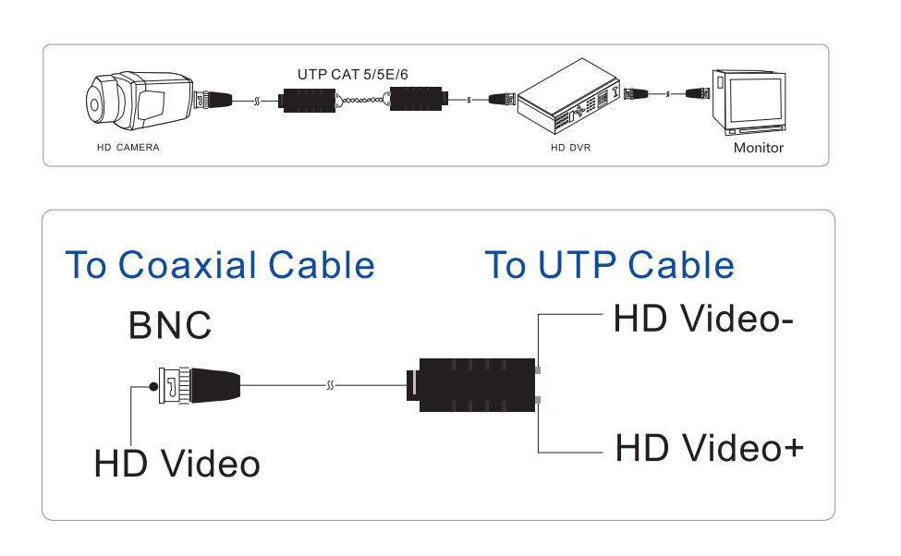

Pictures of this Economical Press-Fitting Terminal Model 1 Channel HD Balun

