HD CVI TVI AHD UTP Economic Type Video Balun
> Model number: STK201P-HD-C2
> Transmission Signal: 1 channel
> Category Type: UTP CAT5/ 5E/ 6
> Twisted-pair Video Connector: BNC-M
> Compatible Format: HDCVI/HDTVI/AHD/CVBS
> Resolution: 720P/1080P/3MP/4MP/5MP/4K(8MP)
Description of this HD CVI TVI AHD UTP Economic Type Video Balun

STK201P-HD-C2 has a mini-coax pigtail lead which allows quick mounting onto fixed cameras, allows in-camera mounting in most dome cameras and allows flexible connection with DVR. Push-pin terminal block allows tool-less connection of UTP cable output. Used in pairs, STK201P-HD-C2 eliminates costly and bulky coaxial cable.

The superior interference rejection and low emissions of the STK201P-HD-C2 allow video signals to coexist in the same wire bundle as telephone, datacom, or damaging voltage spikes. Its crosstalk and noise immunity ensure quality video signals. Widely used in security, teaching industry and other complex system environment.

Specification of this HD CVI TVI AHD UTP Economic Type Video Balun

Model | STK201P-HD-C2
Properties
Transmission Signal | 1 channel
Transmission Distance (Max) | HDCVI 720P: 400M / 1080P: 250M; 4Mp:200M ;5Mp:200M; 8MP: 180M
 | HDTVI 720P/1080P: 250M; 5Mp:200M ; 8MP: 180M
 | AHD 720P: 350M / 1080P: 200M;5Mp:200M; 8MP: 180M
Category Type | UTP CAT 5E/6 (R＜10Ω/100M)
Video Transmission Properties And Port
Coaxial Video Connector | BNC-M
Twisted-pair Video Connector | Press-fitting terminal
Compatible Format | HDCVI, HDTVI, AHD, CVBS
Resolution | 720P/1080P/4MP/5MP/8MP 4K
Anti-interference | ＞60db
Protection
ESD | 1a contact discharge electricity level 3
 | 1b air discharge electricity level 3
 | Per:IEC61000-4-2
Coaxial Cable Connector | 2KV(common-code) Per:IEC61000-4-5
UTP Cable Connector | 2KV(different-code),4KV(common-code),Per:IEC61000-4-5
Impedance
BNC Male | 75 ohms
UTP Cable | 100 ohms
Physical Properties
Shell | ABS
Color | Black
N.W. | 50G
Stability
MTBF | ＞10000H
Environmental
Operating Temperature | -10~55℃
Storage Temperature | -20~70℃
Humidity | 0~95%(non-condensing)

Application of this HD CVI TVI AHD UTP Economic Type Video Balun

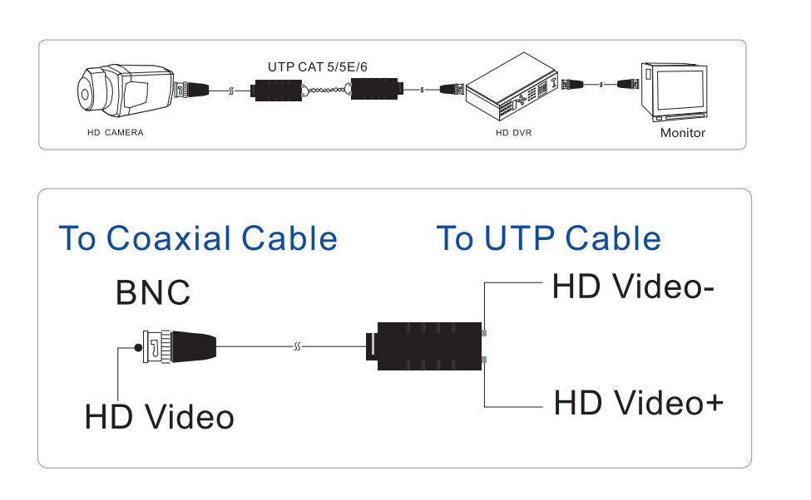

Pictures of this HD CVI TVI AHD UTP Economic Type Video Balun

