1CH Passive HD CVI TVI AHD CVBS Video Balun Transceiver
STK201P-HD-G2 video balun is a passive (non-amplified) device that allows the transmission of real-time CCTV HD video signal via cost-effective Unshielded Twisted Paired (UTP) cable. Support 4K Resolution to 200M Max!
Description of this 1CH Passive HD CVI TVI AHD CVBS Video Balun Transceiver
STK201P-HD-G2 cctv passive video balun is a passive (non-amplified) device that allows the transmission of real-time CCTV HD video signal via cost-effective Unshielded Twisted Paired (UTP) cable. The 201P-HD-G2 CCTV Passive Video Transceiver is compatible with all HD-TVI, HD-CVI, AHD and CVBS analog cameras.
Upside push-pin terminal block allows easy connection of UTP cable output. Used in pairs, STK201P-HD-G2 1CH Passive HD Video Balun eliminates costly and bulky coaxial cable.
The superior interference rejection and low emissions of the STK201P-HD-G2 allow video signals to coexist in the same wire bundle as telephone, datacom, or damaging voltage spikes. 1CH HD Video Balun Transceiver crosstalk and noise immunity ensure quality video signals. Widely used in security, teaching industry and other complex system environment.
Specification of this 1CH Passive HD CVI TVI AHD CVBS Video Balun Transceiver

Model | STK201P-HD-G2
Properties
Transmission Signal | 1 channel
Transmission Distance (Max) | HDCVI 720P:400M / 1080P:250M /4MP:200M / 4K 8MP:200M
 | HDTVI 720P/1080P:250M / 5MP:200M / 4K 8MP:150M
 | AHD 720P:350M / 1080P:200M / 5MP:200M / 4K8MP:150M
Category Type | UTP CAT 5E/6 (R＜10Ω/100M)
Video Transmission Properties And Port
Coaxial Video Connector | BNC-M
Twisted-pair Video Connector | Push-terminal
Compatible Format | HDCVI, HDTVI, AHD, CVBS
Resolution | 720P/1080P/4MP/5MP/8MP 4K
Anti-interference | ＞60db
Protection
ESD | 1a contact discharge electricity level 3
 | 1b air discharge electricity level 3
 | Per:IEC61000-4-2
Coaxial Cable Connector | 2KV(common-code) Per:IEC61000-4-5
UTP Cable Connector | 2KV(different-code),4KV(common-code),Per:IEC61000-4-5
Impedance
BNC Male | 75 ohms
UTP Cable | 100 ohms
Physical Properties
Shell | ABS
Color | Black
N.W. | 25G
Stability
MTBF | ＞10000H
Environmental
Operating Temperature | -10~55℃
Storage Temperature | -20~70℃
Humidity | 0~95%(non-condensing)

Application of this 1CH Passive HD CVI TVI AHD CVBS Video Balun Transceiver
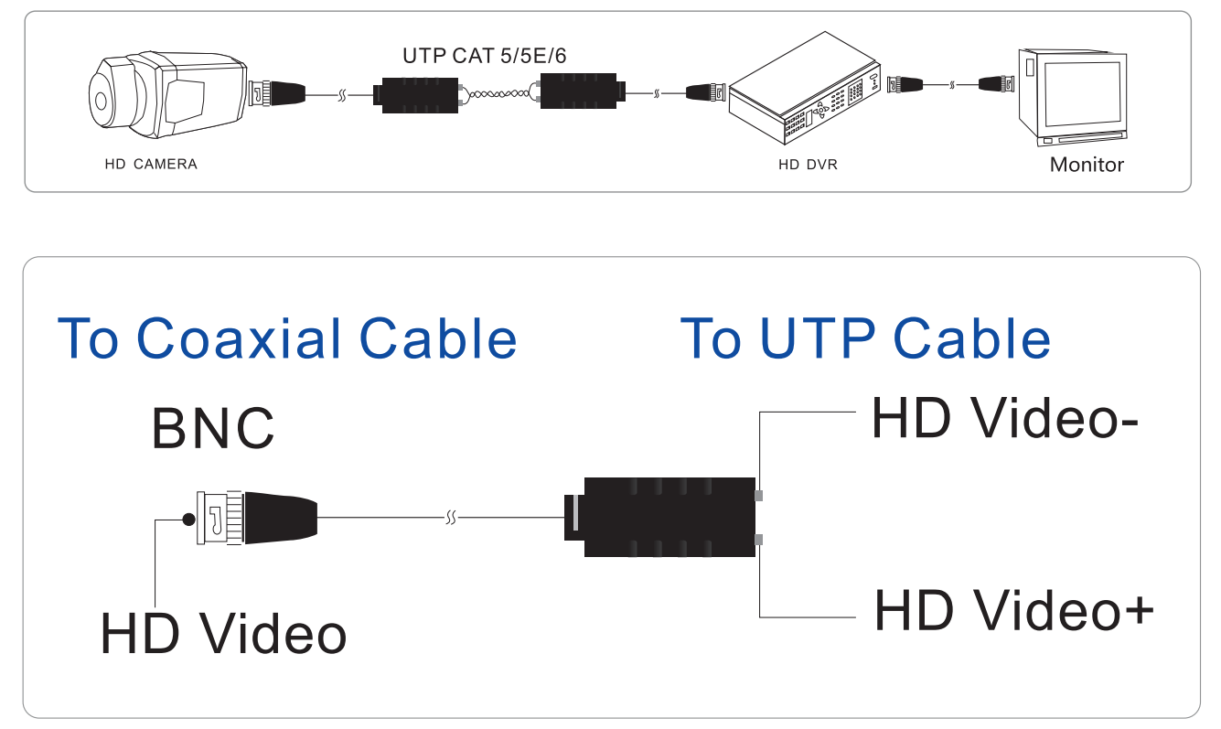

Pictures of this 1CH Passive HD CVI TVI AHD CVBS Video Balun Transceiver

