3CH Active HD Video Receiver
3 channel active Receiver, 9-40V DC input, dual output
Long transmission with passive HD transmitter:
HDCVI 720P/500m 1080P/350m
HDTVI 720P&1080P/350m
AHD 720P/500m 1080P/300m
Dual BNC output, coax up to 300m
Metal outer housing with Screw Terminal,Dip switch for adjustment
Built in High standard TVS for surge protection
Description of this 3CH Active HD Video Receiver
The product is a 3 channel active HD Video Receiver. The product adopts Cat 5/5e/6 UTP cable as transmission medium, it can real-time receive 3CH video signal. It can work together with passive transmitter. It features long transmission distance, good transmission effect, super anti-interference, widely CCTV surveillance system.

Specification of this 3CH Active HD Video Receiver
> 1pc 3CH Active HD video Receiver+2pcs rack-mounting ear; +8pcs rack-mounting screws+1pc Phillips screwdriver
> Power Input: DC 9V~40V.
> Transmission: real-time transfer CVI/TVI/AHD video signal with high quality video.
> Transmission distance with passive transmitter:
HDCVI 720P: 500M / 1080P: 350M;
HDTVI 720P/1080P: 300M;
AHD 720P: 500M / 1080P: 300M;
Analog: 650M
> BNC output max 300m for coaxial cable.
> Function: adopts UTP cable for the transmission, support knob adjustment.
> Protection: wide range voltage DC power input, strong surge protection and anti-interference.
> Structure: delicate design, support MIT rack.

Application of this 3CH Active HD Video Receiver
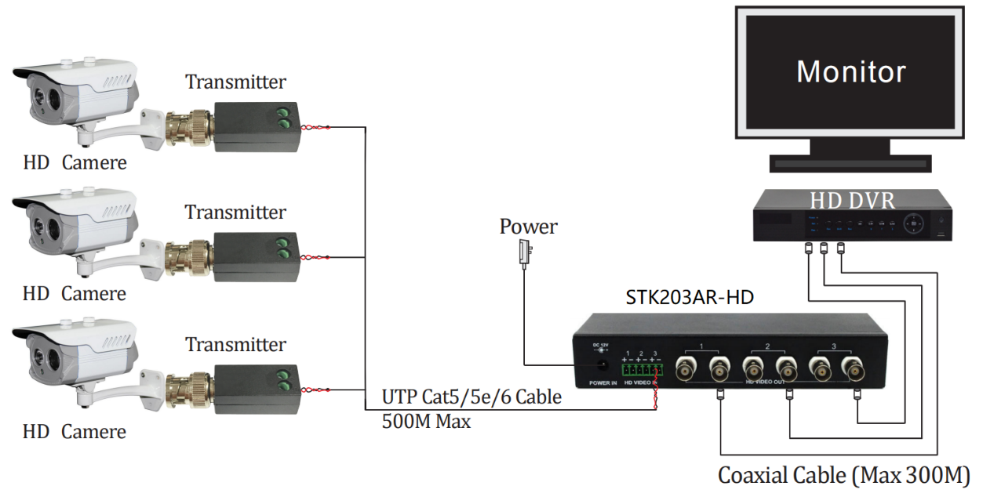
Pictures of this 3CH Active HD Video Receiver
